Project Documentation
AI FAQ Assistant API
AI-Powered FAQ and Customer Support Automation

1. Introduction
The AI FAQ Assistant API is a REST API backend for FAQ and customer-support management. It supports secure user authentication, FAQ CRUD operations, FAQ search and AI-assisted FAQ generation.

Project Information
Project Title: AI FAQ Assistant API
Team ID: SWTID-2026-1297
Team Size: 4
Team Leader: SRIPRIYA P
Email ID: 24bsccs19@cttewc.edc.in
Role: Team Leader & Backend Developer
Team Members:
1. Name: Harini Karthiga G
Email ID: 24bsccs09@cttewc.edu.in
Role: Documentation
2. Name: Monisha T
Email ID: 24bsccs35@cttewc.edu.in
Role: Documentation
3. Name: Daisy rani V
Email ID: 24bsccs34@cttewc.edu.in
Role: PPT
Naan Mudhalvan Backend Development Project

2. Project Overview
The project provides a centralized backend for storing and retrieving FAQ content. Node.js and Express.js handle the API, MongoDB stores the data, and Google Gemini AI is used for AI-powered FAQ generation.
- User registration and login
- JWT authentication and protected routes
- Create, read, update and delete FAQs
- FAQ search and categorization
- AI-powered FAQ generation using Gemini
- Validation and centralized error handling

3. Architecture
The application follows a modular backend / MVC-style structure that separates routing, logic and data access.
Express Server: Handles HTTP requests, routes and JSON responses.
Controllers: Contains authentication, FAQ and AI business logic.
Middleware: Handles authentication, validation and errors.
Models: Defines User and FAQ schemas using Mongoose.
Routes: Defines authentication, FAQ and AI endpoints.
Gemini Service: Connects the API with Google Gemini AI.
MongoDB: Stores user and FAQ information.

4. Setup Instructions

Prerequisites
- Node.js v18 or above
- npm
- MongoDB / MongoDB Atlas
- Visual Studio Code
- Postman or Thunder Client

Installation
npm install
Configure the required database and Gemini credentials in the .env file.
npm start
The current application runs on port 5000.

5. Folder Structure
Code Files
├── src
│ ├── config
│ │ └── db.js
│ ├── controllers
│ │ ├── aiController.js
│ │ ├── authController.js
│ │ └── faqController.js
│ ├── middleware
│ │ ├── authMiddleware.js
│ │ ├── errorMiddleware.js
│ │ └── validationMiddleware.js
│ ├── models
│ │ ├── FAQ.js
│ │ └── User.js
│ ├── routes
│ │ ├── aiRoutes.js
│ │ ├── authRoutes.js
│ │ └── faqRoutes.js
│ ├── services
│ │ └── geminiService.js
│ ├── utils
│ │ └── helpers.js
│ ├── app.js
│ └── server.js
├── .env
├── package.json
├── README.md
└── test_api.js

6. Running the Application
Start the backend server using:
npm start
After successful startup, MongoDB connects and the server listens on port 5000.

7. API Documentation

Authentication APIs
POST /api/auth/register → Register a new user
POST /api/auth/login → Login and receive authentication access

FAQ APIs
POST /api/faqs → Create a FAQ
GET /api/faqs/search?q=configure → Search FAQs

AI API
POST /api/ai/generate-faq → Generate FAQ content using Gemini AI

8. API Testing
API testing is performed using Postman / Thunder Client.
- Registration and login
- FAQ creation and retrieval
- FAQ search
- AI FAQ generation
- Authentication and validation

9. User Interface
This project focuses on backend API development, so there is no separate graphical user interface. The API can be tested through Postman or Thunder Client.

10. Technologies Used
- Node.js – Backend runtime
- Express.js – REST API framework
- MongoDB – Database
- Mongoose – ODM and schema validation
- JWT – Authentication
- bcrypt – Password hashing
- Google Gemini AI – AI-powered FAQ generation

11. Testing
Manual API testing is used to verify the main backend functions.
- User registration and login
- Protected API access
- FAQ CRUD operations
- Search functionality
- AI-generated FAQ response

12. Screenshots / Demo
The following screenshots show the main project execution and API testing outputs.
Output on the terminal once server starts:
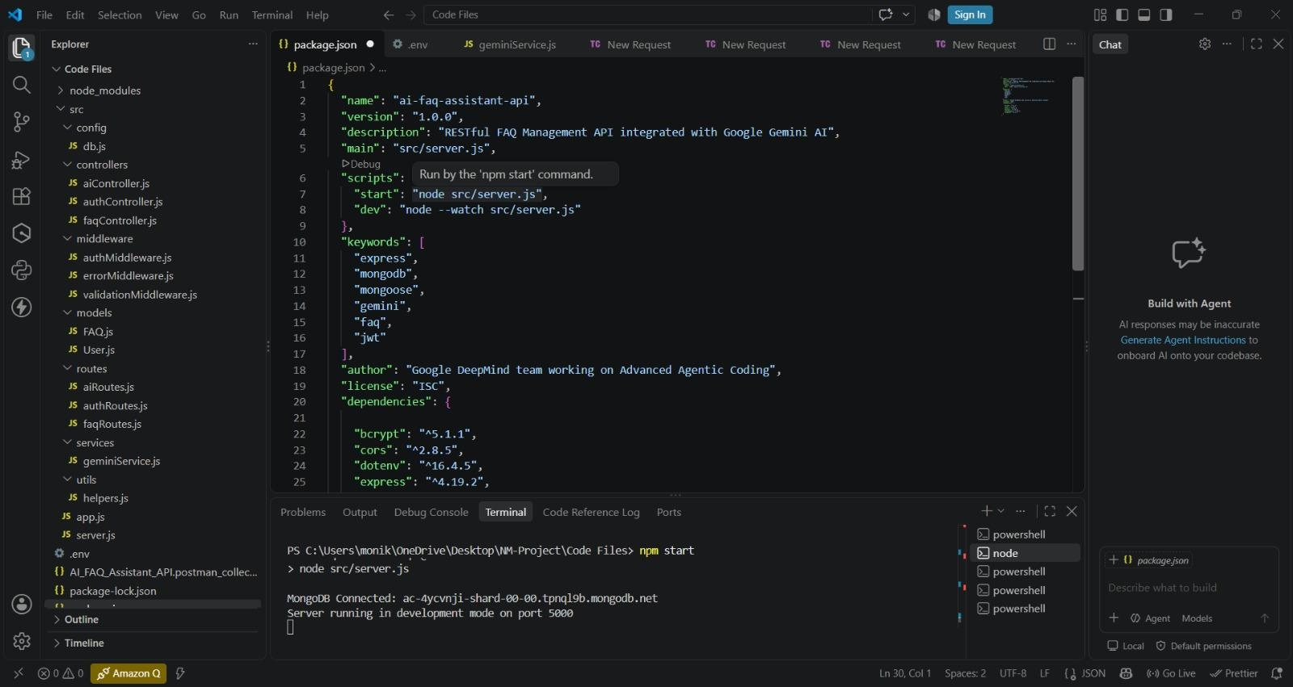
User registration output:
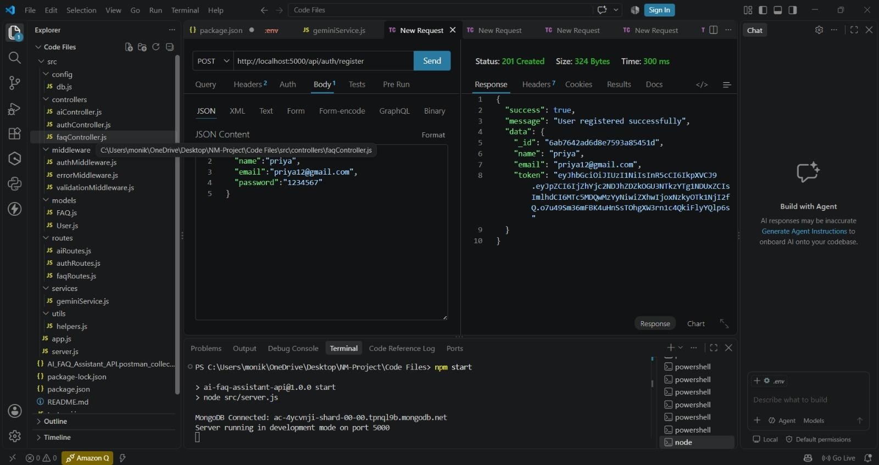

user login output:
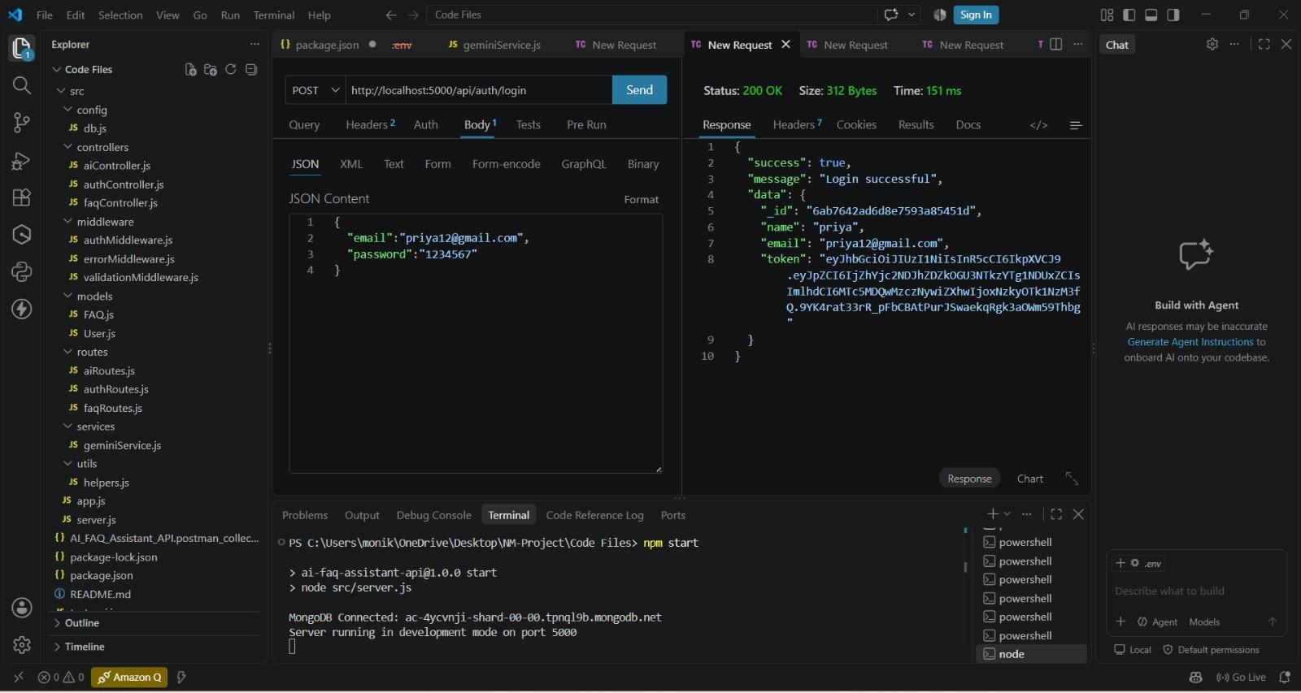

User profile output:
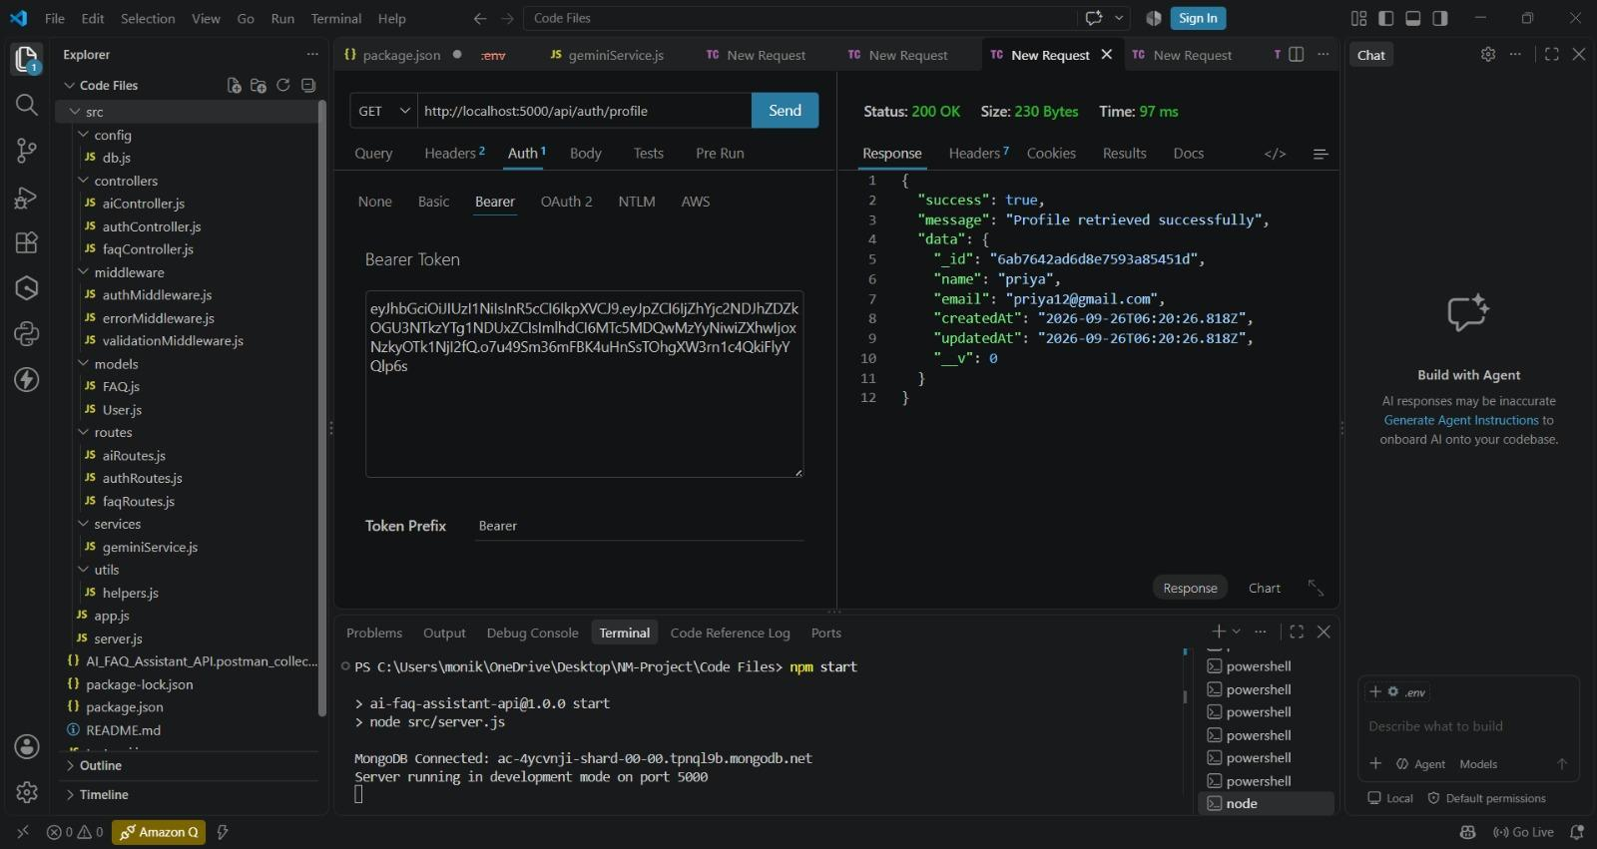

AI-Powered Answer Generation using Gemini AI:
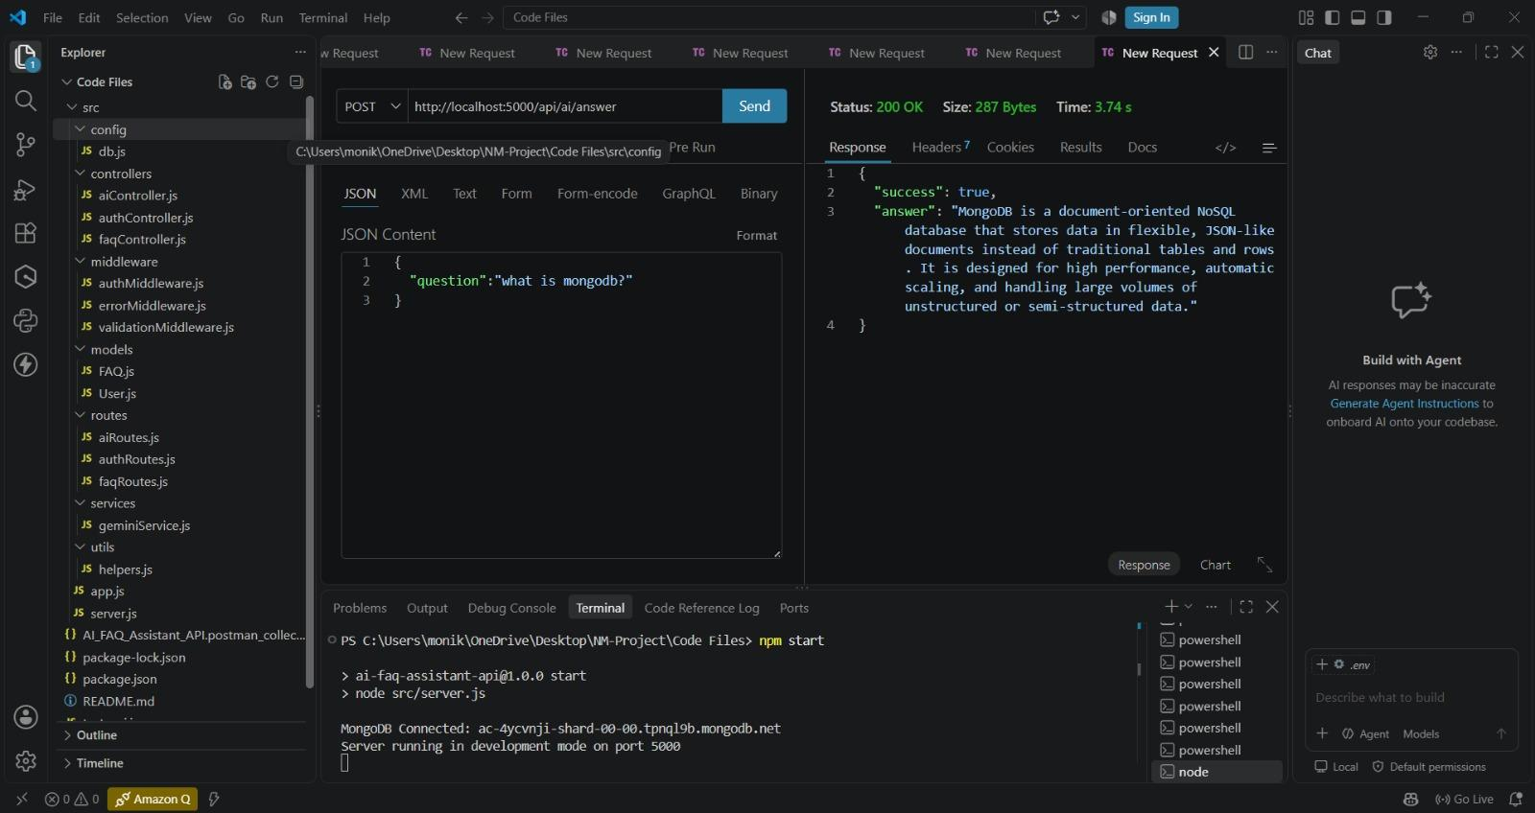

Demo video link :

https://drive.google.com/file/d/17ovLwNVU9F897t-4__6F994D8HChFmXS/view?usp=drivesdk

13. Known Issues
- No separate frontend interface is included.
- The application requires correct environment-variable configuration.
- AI generation depends on valid Gemini API configuration and availability.

14. Future Enhancements
- Add a web-based frontend.
- Improve semantic search and result ranking.
- Add pagination and analytics.
- Expand AI-based customer-support features.
- Deploy the API to a cloud platform.

